-Министерство науки и высшего образования Российской Федерации

Федеральное государственное автономное образовательное учреждение высшего образования

«Национальный исследовательский университет ИТМО»

*Факультет программной инженерии и компьютерной техники*

**Курсовая работа**

по дисциплине

«Дискретная математика»

Вариант №87

Выполнил:

Студент группы P3113

Султанов А.Р.

Преподаватель:

Поляков В.И.

г. Санкт-Петербург

2022г.

# Оглавление

**Оглавление** **2**

**Часть 2** **3**

# Часть 2

Вариант 87

| N | Выполняемые операции | Число переменных | | Разрядность операндов | | Знаки | Доп.код | Фиксация переноса/заема/переполнения | Для деления формирование | | Запрещенная нулевая комбинация | |
| --- | --- | --- | --- | --- | --- | --- | --- | --- | --- | --- | --- | --- |
| Входных | Выходных | A | B | Частного | Остатка | A | B |
| 87 | $C=(A+B)_{mod 7}$ | 5 | 4 | 2 | 3 | - | - | - | - | - | - | - |

|  |  |  |  |  |  |  |  |  |
| --- | --- | --- | --- | --- | --- | --- | --- | --- |
| 0 | 0 | 0 | 0 | 0 | 0 | 0 | 0 | 0 |
| 0 | 0 | 0 | 0 | 1 | 0 | 0 | 0 | 1 |
| 0 | 0 | 0 | 1 | 0 | 0 | 0 | 1 | 0 |
| 0 | 0 | 0 | 1 | 1 | 0 | 0 | 1 | 1 |
| 0 | 0 | 1 | 0 | 0 | 0 | 1 | 0 | 0 |
| 0 | 0 | 1 | 0 | 1 | 0 | 1 | 0 | 1 |
| 0 | 0 | 1 | 1 | 0 | 0 | 1 | 1 | 0 |
| 0 | 0 | 1 | 1 | 1 | 0 | 0 | 0 | 0 |
| 0 | 1 | 0 | 0 | 0 | 0 | 0 | 0 | 1 |
| 0 | 1 | 0 | 0 | 1 | 0 | 0 | 1 | 0 |
| 0 | 1 | 0 | 1 | 0 | 0 | 0 | 1 | 1 |
| 0 | 1 | 0 | 1 | 1 | 0 | 1 | 0 | 0 |
| 0 | 1 | 1 | 0 | 0 | 0 | 1 | 0 | 1 |
| 0 | 1 | 1 | 0 | 1 | 0 | 1 | 1 | 0 |
| 0 | 1 | 1 | 1 | 0 | 0 | 0 | 0 | 0 |
| 0 | 1 | 1 | 1 | 1 | 0 | 0 | 0 | 1 |
| 1 | 0 | 0 | 0 | 0 | 0 | 0 | 1 | 0 |
| 1 | 0 | 0 | 0 | 1 | 0 | 0 | 1 | 1 |
| 1 | 0 | 0 | 1 | 0 | 0 | 1 | 0 | 0 |
| 1 | 0 | 0 | 1 | 1 | 0 | 1 | 0 | 1 |
| 1 | 0 | 1 | 0 | 0 | 0 | 1 | 1 | 0 |
| 1 | 0 | 1 | 0 | 1 | 0 | 0 | 0 | 0 |
| 1 | 0 | 1 | 1 | 0 | 0 | 0 | 0 | 1 |
| 1 | 0 | 1 | 1 | 1 | 0 | 0 | 1 | 0 |
| 1 | 1 | 0 | 0 | 0 | 0 | 0 | 1 | 1 |
| 1 | 1 | 0 | 0 | 1 | 0 | 1 | 0 | 0 |
| 1 | 1 | 0 | 1 | 0 | 0 | 1 | 0 | 1 |
| 1 | 1 | 0 | 1 | 1 | 0 | 1 | 1 | 0 |
| 1 | 1 | 1 | 0 | 0 | 0 | 0 | 0 | 0 |
| 1 | 1 | 1 | 0 | 1 | 0 | 0 | 0 | 1 |
| 1 | 1 | 1 | 1 | 0 | 0 | 0 | 1 | 0 |
| 1 | 1 | 1 | 1 | 1 | 0 | 0 | 1 | 1 |

$c_{1}=0$

$c_{2}$:

$a_{1}=0$

| $a_{2}b_{1}/b_{2}b_{3}$ | 00 | 01 | 11 | 10 |
| --- | --- | --- | --- | --- |
| 00 | 0 | 0 | 0 | 0 |
| 01 | **1** | **1** | 0 | **1** |
| 11 | **1** | **1** | 0 | 0 |
| 10 | 0 | 0 | **1** | 0 |

|  | 00 | 01 | 11 | 10 |
| --- | --- | --- | --- | --- |
| 00 | 0 | 0 | **1** | **1** |
| 01 | **1** | 0 | 0 | 0 |
| 11 | 0 | 0 | 0 | 0 |
| 10 | 0 | **1** | **1** | **1** |

$с_{3}$:

$a_{1}=0$

| $a_{2}b_{1}/b_{2}b_{3}$ | 00 | 01 | 11 | 10 |
| --- | --- | --- | --- | --- |
| 00 | 0 | 0 | **1** | **1** |
| 01 | 0 | 0 | 0 | **1** |
| 11 | 0 | **1** | 0 | 0 |
| 10 | 0 | **1** | 0 | **1** |

|  | 00 | 01 | 11 | 10 |
| --- | --- | --- | --- | --- |
| 00 | **1** | **1** | 0 | 0 |
| 01 | **1** | 0 | **1** | 0 |
| 11 | 0 | 0 | **1** | **1** |
| 10 | **1** | 0 | **1** | 0 |

$с_{4}$:

$a_{1}=0$

| $a_{2}b_{1}/b_{2}b_{3}$ | 00 | 01 | 11 | 10 |
| --- | --- | --- | --- | --- |
| 00 | 0 | **1** | **1** | 0 |
| 01 | 0 | **1** | 0 | 0 |
| 11 | **1** | 0 | **1** | 0 |
| 10 | **1** | 0 | 0 | **1** |

|  | 00 | 01 | 11 | 10 |
| --- | --- | --- | --- | --- |
| 00 | 0 | **1** | **1** | 0 |
| 01 | 0 | 0 | 0 | **1** |
| 11 | 0 | **1** | **1** | 0 |
| 10 | **1** | 0 | 0 | **1** |

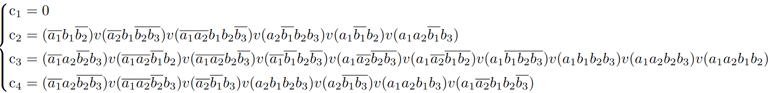

$S_{Q}^{1}=0, S_{Q}^{2}=29, S_{Q}^{3}=50, S_{Q}^{4}=34$

$S_{Q}=113$

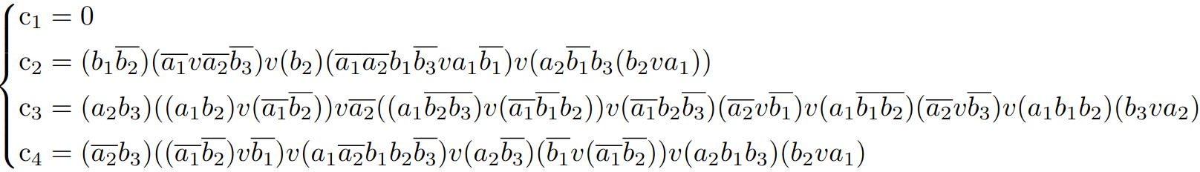

$S_{Q}^{1}=0, S_{Q}^{2}=26, S_{Q}^{3}=46, S_{Q}^{4}=32$

$S_{Q}=104$

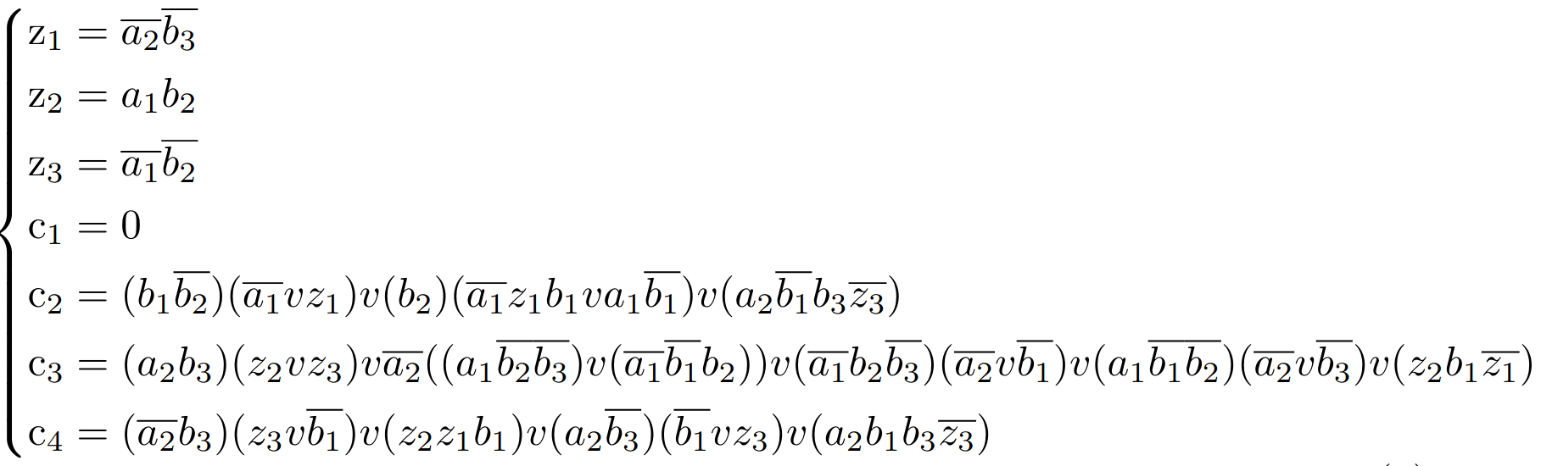

$S_{Q}^{Z1}=2, S_{Q}^{Z2}=2, S_{Q}^{Z3}=2,{ S}_{Q}^{1}=0, S_{Q}^{2}=21, S_{Q}^{3}=35, S_{Q}^{4}=21$

$S_{Q}=83$ (+2 за инверторы для z1, z3)

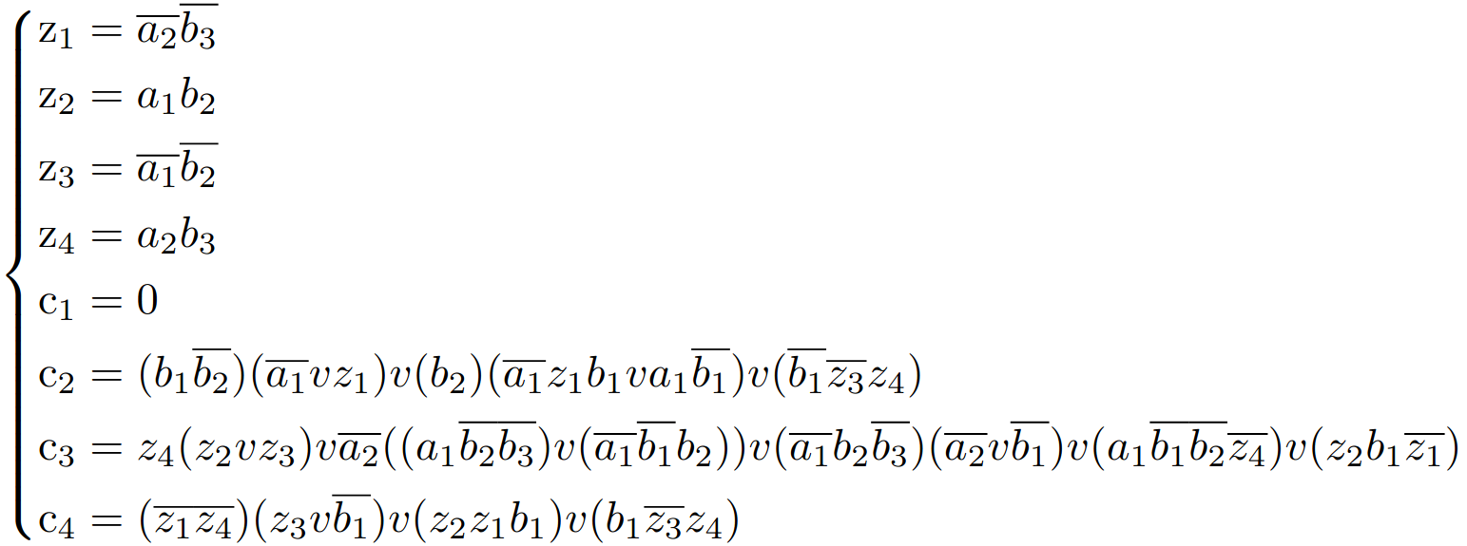

$S_{Q}^{Z1}=2, S_{Q}^{Z2}=2, S_{Q}^{Z3}=2, S_{Q}^{Z4}=2,{ S}_{Q}^{1}=0, S_{Q}^{2}=20, S_{Q}^{3}=32, S_{Q}^{4}=14$

$S_{Q}=74$ (+3 за инверторы для z1, z3, z4)

$S_{Q}=77$

$T_{c2}=5τ, T_{c3}=4τ, T_{c4}=4τ, T=5τ$

$f(00000)=0000$

$f(11111)=0011$

